Hands-on 1: Foundations: Variables, Operators, and Control Flow

1. Prerequisites
Terminal Access: Open your VS Code terminal.
Environment Check: Run `go version` to ensure the compiler is active.

2. Why are we doing this?
Go is a statically typed language. Unlike Python or JavaScript, Go wants to know exactly what kind of data is in a variable at compile time. This prevents a huge category of bugs. Today, we learned how to talk to the Go compiler to manage data and logic.

3. Objective
- Master 3 ways to declare variables.
- Understand the difference between `int`, `float64`, and `string`.
- Use arithmetic and logical operators.
- Build a robust CLI Calculator with error handling.

4. Steps To Follow

Step 1: Variable Declaration Deep-Dive
Create `01_variables.go`. We will explore how Go handles memory and types.

package main
import "fmt"
func main() {
// 1. Formal declaration (Global/Package level style)
var username string = "Gopher_One"
// 2. Type Inference (Go guesses the type)
var age = 25
// 3. Short Declaration (The "Inside-Function" favorite)
// Note: This cannot be used outside of a function.
isProgrammer := true

// equivalent to var isProgrammer bool = true
// 4. Declaring multiple variables at once
var width, height int = 100, 50
fmt.Println("--- User Profile ---")
fmt.Printf("Name: %s\nAge: %d\nActive: %t\nDimensions: %dx%d\n",
username, age, isProgrammer, width, height)
}

Run command:

go run 01_variables.go

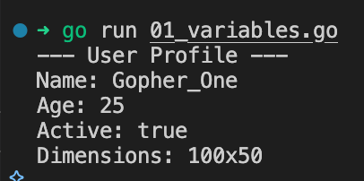
Key Concept: `Printf` uses "verbs" like `%s` (string) and `%d` (integer) to format output. This is a core Go pattern.

Step 2: Operators & Math
Create `02_operators.go`. In Go, you cannot add an `int` to a `float64` without explicit conversion.

package main
import "fmt"
func main() {
a, b := 10, 3
// Arithmetic
sum := a + b
diff := a - b
prod := a * b
quot := a / b // Integer division! (Result is 3, not 3.33)
rem := a % b // Remainder (Modulo)
fmt.Printf("Sum: %d, Difference : %d, Product: %d, Division: %d, Remainder: %d\n", sum, diff, prod, quot, rem)
// Type Conversion
// To get a decimal result, we must convert to float64
preciseDiv := float64(a) / float64(b)
fmt.Printf("Precise Division: %.2f\n", preciseDiv)
}

Run command:
go run 02_operators.go

Step 3: Control Flow (Decision Making)
Create `03_logic.go`. We will use `if` for ranges and `switch` for specific values.

package main
import "fmt"
func main() {
temp := 25
// IF/ELSE: Best for ranges or complex logic
if temp > 30 {
fmt.Println("It's hot outside.")
} else if temp >= 15 && temp <= 30 {
fmt.Println("Perfect weather.")
} else {
fmt.Println("It's cold.")
}
// SWITCH: Best for specific "cases"
day := "Monday"
switch day {
case "Saturday", "Sunday":
fmt.Println("Weekend!")
default:
fmt.Println("Work day.")
}
}

Command to run:
go run 03_logic.go

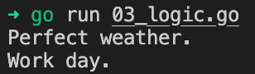

5. Mini-Project: The "Smart" Calculator
Create `calculator.go`. This combines everything: variables, input, logic, and error handling.

package main
import (
"fmt"
"os"
)
func main() {
var n1, n2 float64
var op string
fmt.Println("##########################")
fmt.Println("# GO SMART CALCULATOR #")
fmt.Println("##########################")
// Input for the first number
fmt.Print("Enter first number: ")
_, err1 := fmt.Scan(&n1)
if err1 != nil {
fmt.Println("Error: Please enter a valid number.")
os.Exit(1)
}
// Input for the operator
fmt.Print("Enter operator (+, -, *, /): ")
fmt.Scan(&op)
// Input for the second number
fmt.Print("Enter second number: ")
_, err2 := fmt.Scan(&n2)
if err2 != nil {
fmt.Println("Error: Please enter a valid number.")
os.Exit(1)
}
fmt.Print("RESULT: ")
// Logic to handle different mathematical operations
switch op {
case "+":
fmt.Printf("%.2f + %.2f = %.2f\n", n1, n2, n1+n2)
case "-":
fmt.Printf("%.2f - %.2f = %.2f\n", n1, n2, n1-n2)
case "*":
fmt.Printf("%.2f * %.2f = %.2f\n", n1, n2, n1*n2)
case "/":
// Prevent division by zero to avoid program crash
if n2 == 0 {
fmt.Println("Error: Cannot divide by zero!")
} else {
fmt.Printf("%.2f / %.2f = %.2f\n", n1, n2, n1/n2)
}
default:
fmt.Println("Unknown Operator. Please use +, -, *, or /.")
}
}

Command to run:
go run calculator.go

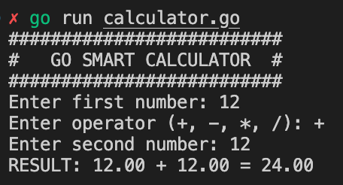

6. Checklist of Accomplishments
[ ] Multi-style Declarations: Used `var`, type inference, and `:=`.
[ ] Formatting: Used `Printf` with correct verbs (`%f`, `%d`).
[ ] Explicit Conversion: Converted `int` to `float64` for math.
[ ] Error Handling: Added a basic check for non-numeric input using `err`.
[ ] Logical Gates: Used `&&` (AND) and `||` (OR) in if-statements.

7. Conclusion
In this hands-on, you've moved beyond simple text. You've learned that Go is strict about types for a reason—it makes your code predictable. You've also seen how `fmt.Scan` returns more than just data; it returns an error status, which is the "Go way" of writing reliable software.

Congrats!
You've built a real-world CLI tool. Your calculator doesn't just do math; it validates input and handles crashes.

